Lab – Self-Portrait

In this lab, you will explore SNAP and create a simple "self-portrait" program to introduce yourself to your instructors and classmates.

1. Open SNAP ([**http://snap.berkeley.edu/run**](http://snap.berkeley.edu/run)) on your computer and spend a few minutes looking around, trying things out, and seeing what the language can do. Don't worry about understanding everything completely-- we'll go through things in a lot more detail soon. Just try to get a sense of some of the basic capabilities.
2. Write down three things you found that SNAP can do and how to do them. Be as specific as you can!

|  |  |
| --- | --- |
| **SNAP can do this...** | **If I do this...** |
| 1. |  |
| 2. |  |
| 3. |  |

1. Find a partner and compare notes. Share your findings with your partner and ask him or her about what he or she learned. Write down the three capabilities your partner found below.

|  |  |
| --- | --- |
| **SNAP can do this...** | **If I do this...** |
| 1. |  |
| 2. |  |
| 3. |  |

1. Create an account in SNAP.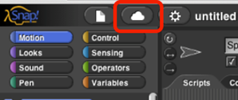

In order to save your programs, the first thing you'll need to do is make an account. In the snap browser window, find the cloud-shaped button in the top toolbar on the upper left corner of the window: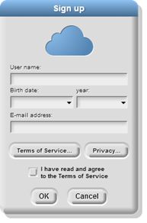

Click it, select the “sign-up” option in the menu, and follow the instructions there. You will need to check your email after crating your account to get your initial password.

1. Using what you've learned and other things you might discover, create a SNAP program that describes yourself..a self-portrait of sorts.
   1. Before you begin save. Save this project as Self-Portrait.
   2. Your program can take whatever form and use whatever SNAP tools and blocks you want. Make sure that somehow, at some point in your program you show the following information:
      * + Your name
        + Your current grade
        + Your age
        + Your favorite class in school
        + One of your hobbies or interests
        + Any previous programming or computer experience you have
        + Career goal
   3. Once your program is complete save then share
   4. Copy and Paste url here:____________________________________________
   5. Turn in assignment.